A Project Report On

FAKE DISCOUNT OFFER DETECTOR

Submitted in partial fulfillment of the requirement for the BCA Semester-4 Python Programming Subject Final Examination.
BACHELOR OF COMPUTER APPLICATIONS
(B.C.A.)

Academic Year 2025 – 26

DURNA PRIYANKA(92400527301)

Internal Guide
Prof. Tirth Bhadeshiya



Rajkot-Morbi Road, At & PO : Gauridad, Rajkot 360 003. Gujarat. India.
CONTENTS

Chapters | Particulars | Page No.
1 | SYNOPSIS
2  2.1  2.2  2.3  2.4 | PREAMBLE  General Introduction  Statement of Problem  Objective and Scope of the Study  Module Description with functionality
3  3.1  3.2  3.3  3.4 | SYSTEM DESIGN AND DEVELOPMENT  Data Flow Diagram (DFD)  Table Structure  Menu Design  Screen Design (Screen shots with short description)
4 | CONCLUSION
5 | LEARNING DURING PROJECT WORK
6  6.1  6.2 | BIBLIOGRAPHY  Online References  Offline References

FIGURE INDEX

Sr. No. | Figure No. | Particulars | Page No.
1 | Fig. 3.1.1 | Level 0 dfd
2 | Fig.3.1.2 | Level 1 dfd

TABLE INDEX

Sr. No. | Table No. | Particulars | Page No.
1
2
3
4
5
6
7

FAKE DISCOUNT OFFER DETECTOR
Project Report

1.SYNOPSIS
The Fake Discount Offer Detector is a web-based application developed using Python and Flask. The main objective of this project is to analyze discount offers and determine whether they are genuine or fake.
In today’s digital world, many online platforms provide attractive discount offers to users. However, some of these offers are misleading or fraudulent, such as extremely high discounts or unrealistic combo deals like “Buy 1 Get 2 Free.” This project helps in identifying such fake offers using rule-based text analysis.
The system works by taking an offer as input from the user and processing it through different checks such as keyword detection, discount percentage analysis, and combo offer validation. Based on these checks, the system calculates a score and classifies the offer as either genuine or fake, along with a confidence level.
The application provides a simple and user-friendly interface where users can easily input any offer and get instant results. It also includes additional features like examples of real and fake offers and multiple modules for better usability.

PREAMBLE
📄 PREAMBLE
2.1 General Introduction
In the modern digital era, e-commerce platforms and online shopping websites have become an essential part of everyday life. Customers are frequently attracted by various discount offers, promotional deals, and combo schemes. While many of these offers are genuine, a large number of them are misleading or completely fake. These fake offers often use attractive phrases such as “Flat 90% Discount,” “Limited Time Deal,” or “Buy 1 Get 3 Free” to grab user attention.
Such offers are designed to exploit user psychology and create urgency, which may lead users to make quick and uninformed decisions. As a result, users may face financial loss, receive low-quality products, or fall into online scams. Therefore, there is a strong need for a system that can automatically analyze and verify the authenticity of such discount offers.
The Fake Discount Offer Detector project is designed to address this issue. It uses rule-based logic and text analysis techniques to examine the content of offers and determine whether they are genuine or suspicious. This system helps users make informed decisions and increases awareness about fraudulent marketing practices.

2.2 Statement of Problem
One of the major challenges faced by online users today is the inability to distinguish between genuine and fake discount offers. Many fraudulent sellers use exaggerated discounts and unrealistic combinations to attract customers. Offers such as “90% discount on all products” or “Buy 1 Get 3 Free” are often too good to be true, yet many users fail to recognize them as scams.
Currently, there is no simple and easily accessible tool that allows users to verify the authenticity of such offers before making a purchase. This lack of awareness and verification leads to an increased risk of fraud and customer dissatisfaction.
Therefore, the problem is to design and develop a system that can:
- Analyze discount offers automatically
- Identify suspicious patterns and keywords
- Classify offers as fake or genuine
- Provide quick and reliable results to users

2.3 Objective and Scope of the Study
Objectives
The main objectives of this project are:
- To develop a system that can detect fake discount offers accurately
- To analyze offer text using keywords, patterns, and logical rules
- To identify unrealistic discount percentages and misleading combo offers
- To provide a simple and interactive user interface for easy usage
- To generate a confidence score indicating the reliability of the result

Scope of the Study
The scope of this project includes:
- The system works on text-based input provided by the user
- It can be used for analyzing offers from websites, messages, or advertisements
- It is suitable for educational purposes and basic fraud detection
- The system can be extended in the future using machine learning and AI techniques for higher accuracy
- It can be integrated into e-commerce platforms or browser extensions
However, the current system is limited to rule-based analysis and does not use real-time data or external APIs.

2.4 Module Description with Functionality
The project is divided into multiple modules to ensure proper organization and functionality:
1. Home Module
The Home Module acts as the main interface of the application. It provides navigation links to all other modules such as detection, examples, features, and contact pages. This module ensures that users can easily move between different sections of the application.

2. Detection Module
This is the core module of the system. In this module, the user enters a discount offer in the input field. The system processes the input and performs multiple checks such as:
- Combo offer validation (Buy X Get Y)
- Discount percentage analysis
- Keyword detection
Based on these checks, the system calculates a score and classifies the offer as fake or genuine along with a confidence level.

3. Examples Module
The Examples Module provides sample offers to help users understand the difference between real and fake offers. It includes:
- Fake offer examples (e.g., Buy 1 Get 3 Free, 90% discount)
- Genuine offer examples (e.g., Buy 1 Get 1 Free, 30% discount)
This module improves user awareness and helps in better understanding of the system.

4. Features Module
This module highlights the key features of the system, such as:
- Detection of fake offers
- Combo validation logic
- Keyword-based analysis
- Confidence score generation
It provides a clear overview of what the system can do.

5. About & Contact Module
The About section provides information about the project, its purpose, and development details.
The Contact section includes basic contact information such as email or developer details for user queries or feedback.

Overall, these modules work together to provide a complete and user-friendly system for detecting fake discount offers.

3. SYSTEM DESIGN AND DEVELOPMENT

3.1 Data Flow Diagram (DFD)
Level 0:
User → System → Output
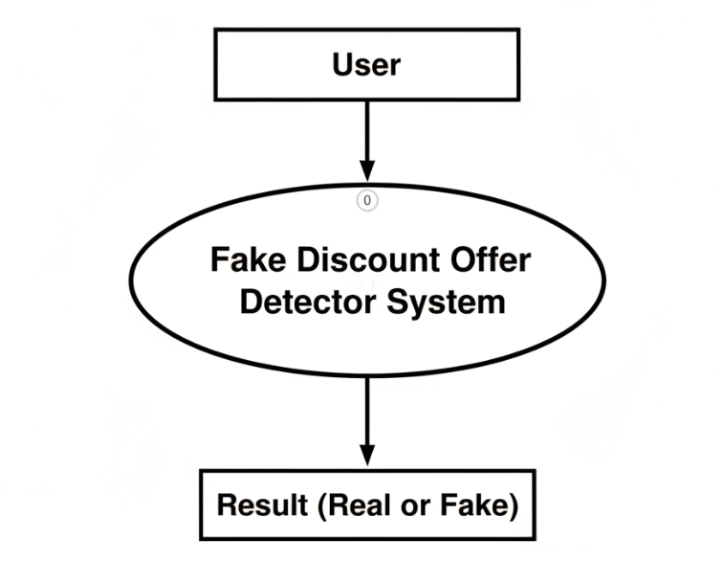
Fig. 3.1.1- Level 0 DFD
Level 1:
User Input → Processing → Analysis → Decision → Output
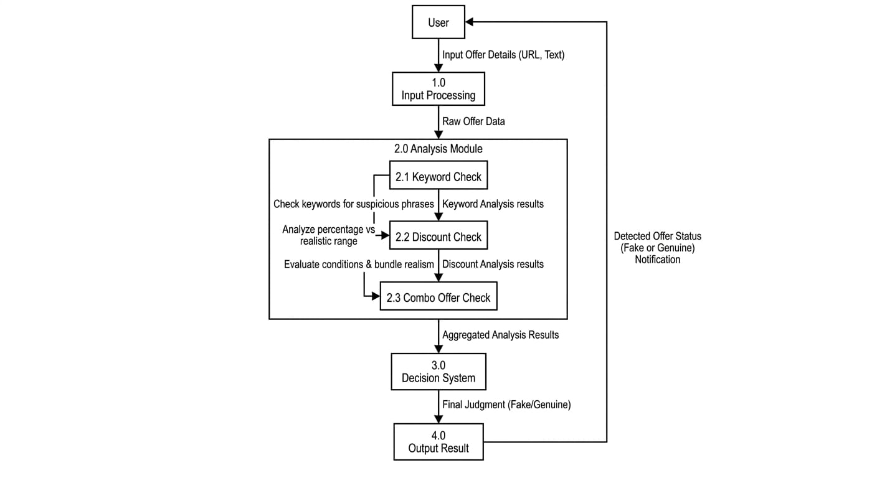
Fig. 3.1.2 Level 1 DFD

3.2 Table Structure
TABLE:OFFER
Field Name | Data Type | Description
offer_id | INT (PK) | Unique ID
offer_text | VARCHAR(255) | User entered offer
result | VARCHAR(50) | Fake / Genuine
confidence | INT | Confidence percentage
date_checked | DATETIME | Date & time of check

Field Name Data Type Description  rule_id INT (PK) Unique ID  min_percent INT Minimum discount  max_percent INT Maximum discount  status VARCHAR(20) Fake / Genuine | TABLE: Discount_Rules
TABLE: Discount_Rules
👉 Stores discount logic
Field Name | Data Type | Description
rule_id | INT (PK) | Unique ID
min_percent | INT | Minimum discount
max_percent | INT | Maximum discount
status | VARCHAR(20) | Fake / Genuine

TABLE: Combo_Offers
👉 Stores combo validation
Field Name | Data Type | Description
combo_id | INT (PK) | Unique ID
buy_quantity | INT | Buy quantity
get_quantity | INT | Free quantity
status | VARCHAR(20) | Fake / Genuine

3.3 Menu Design
Home
Check Offer
Examples
Features
About
Contact

3.4 Screen Design
Screens included:
1. Home Page
2. Offer Detection Page
3. Examples Page
4. Features Page
5. About Page

4. CONCLUSION
The system successfully identifies fake and genuine offers using rule-based logic. It helps users avoid scams and increases awareness about unrealistic deals.

5. LEARNING DURING PROJECT WORK
- Learned Python programming
- Learned Flask framework
- Learned web development basics
- Improved logic building and problem-solving skills

6. BIBLIOGRAPHY

6.1 Online References
https://www.python.org
https://flask.palletsprojects.com
https://www.w3schools.com
https://stackoverflow.com

6.2 Offline References
Class notes
Study materials

